Discussion F Activity

March 3rd & 5th

Synchronous Rhythms in Nature

Overview

In the Tuesday lecture this week we study the notion of “self-organization” among groups of simple organisms, from which surprisingly complex structures and behaviors can arise. One particularly striking example of this is the ability of diverse kinds of organisms to synchronize their behavior without any overall control over the whole group. Consider for example the following well-known phenomena [1]:
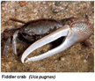
- During mating season, groups of male fiddler crabs have been observed waving their large claws together as a group;
- Some populations of marine organisms, including tropical marine sponges and red abalones, synchronize their release of sperm and eggs;
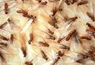
- Termites exhibit synchronous chewing;
- Ants demonstrate a variety of synchronized activities, including foraging and alarm drumming; and
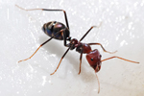
- Human females living in a group will synchronize their menstrual cycles.

There are a variety of mechanisms at work here, usually involving communication through sight, smell, or touch, in conjunction with a neural or hormonal “oscillator” which regulates the rhythm. The important thing to realize, however, is that there is no “conductor” beating time and keeping everyone together---the rhythm arises in the group spontaneously; it is scientists would call “self-organizing.”

Synchronous Flashing in Fireflies

Perhaps the most dramatic example of “self-organizing” behavior in the animal kingdom is the synchronous flashing large groups (sometime as many as 10,000) of fireflies. The first record of this is from 1727, when the Dutch physician Engelbert Kaempfer observed it in Tailand:
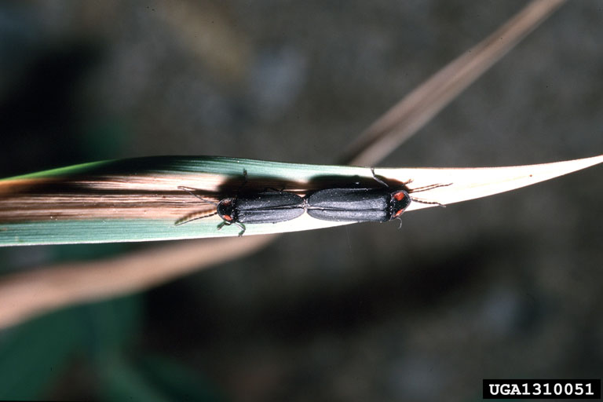
“The Glowworms…. Represent another shew, which settle on some Trees, like a fiery cloud, with this surprising circumstance, that a whole swarm of these Insects, having taken possession of one Tree, and spread themselves over its branches, sometimes hide their Light all at once, and a moment after make it appear again with the utmost regularity and exactness, as if they were in perpetual Systole and Diastole” (quoted in [1]).

Contemporary accounts describe a bewilderingly variety of complex light displays (that have been compared with the light show used to communicate with the aliens in Close Encounters of the Third Kind):

"More than three centuries later Porter observed a very different behavior in far southwestern Indiana in which, from the ends of a long row of tall riverbank trees, synchronized flashes '...began moving toward each other, met at the middle, crossed and traveled to the ends, as when two pebbles are dropped simultaneously into the ends of a long narrow tank of water...'

"In 1961 Adamson described a still different type of display, the first from Africa: 'It is then too that one sees the great belt of light, some ten feet wide, formed by thousands upon thousands of fireflies whose green phosphorescence bridges the shoulder-high grass. The fluorescent band composed of these tiny organisms lights up and goes out with a precision that is perfectly synchronized, and one is left wondering what means of communication they possess which enables them to coordinate their shining as though controlled by a mechanical device' " [2].

A good early treatment of this is to be found in the Scientific American article written by John Buck in 1972 [3].

In this discussion we are going to try to understand how the self-organization of firefly flashing could happen. We will several experiments to understand the way centralized control could organize rhythmic tapping, and several to understand self-organized tapping. If there is enough time left, an optional simulation of firefly flashing using flashlights has been included.

Demonstration One

Investigation: What is the reaction time of the class as a group?

Experiments

- Close your eyes and hold a coin (or pen, or something rigid and inexpensive) in your hand. Wait for the discussion leader to tap his or her coin on the tabletop. When you hear the tap, tap your coin as quickly as possible.

Question: How quickly do you estimate that the average member of the group can respond in the first demonstration?

[Discussion for leaders: Experiments show that few people can respond in less than 150 milliseconds. Student will not be able to measure the time, of course, but should get a sense that we can respond in less than a second, but not instantaneously. There must be a delay. The point of this is to set a baseline for how quickly you can respond to some centralized leader. ]

Demonstration Two

Investigation: What are the mechanisms for synchronizing with a leader?

Experiments

- Close your eyes and again try to echo the tapping of the discussion leader. This time the instructor will tap a regular rhythm of about 1 tap a second.

- Again, echo the rhythm of the instructor, who will now tap out a more complex rhythm (1, 2, 3, 4 &, or three quarter notes and two eighth notes).

- Again, echo the rhythm of the instructor, who will tap out a regular rhythm that varies in speed, starting at about 1 tap/second and speeding up and slowing down irregularly.

Question: For each experiment, how long did it take the class to synchronize? Did they do so on the basis of reaction time or some other mechanism? What would be a likely mechanism?

[Discussion: Class obviously “learns” the pattern after an iteration or two. When it changes they try to keep up based on their learning of the new pattern. They keep track of the rhythm consciously and deliberately, as if listening to a song. Be sure to emphasize that this is NOT the regulatory mechanism used in the motivating examples we started with. However, in this simple experiment, it is ok that this part of the simulation is not equivalent.]

Question: What is the precise reason that the absolute synchrony of the class in the case of a regular rhythm could NOT be due to reacting to the signal of the leader for each tap?

[Discussion: Because the variance from the beat in the average case is much less than the minimum reaction time. If coordination were on the basis of the leader’s tap, there would be a delay, similar to in the first experiment]

Demonstration Three

Investigation: Can the group synchronize without a leader?

Experiments

- Put your desks in a circle so that you have a neighbor to your left, to your right, and can look at the people on the other side of the circle.

- Close your eyes and tap your coin on the tabletop in an easy, regular rhythm, different from the rhythms just done above (try not to let your memory as a group affect the experiment!), trying to synchronize with the taps of your neighbors to the left and right. Don’t worry about the group as a whole, just think about trying to sound like your neighbors Repeat the experiment several times. Each time, each person should try to do a different speed rhythm than previously (we don’t want memory to play a role!).

- Open your eyes and start to tap your coin on the table top in an easy, regular rhythm, again trying to make it different from the rhythm just produced. This time, pick ONE person at random from the entire group (not necessarily near you), look him or her, and try to synchronize with that one person Again, repeat the experiment several times.

Question: What rhythm did the group synchronize to (if they did) in the first case? How long did it take to synchronize? What explanation can you come up with for this phenomenon? Why did it happen so slowly or so fast?

[Discussion: Stabilization should occur fairly quickly. The mechanism is basically that variance in tapping speed basically decreases over the group as a whole because local groups are trying to synchronize. Everyone does his or her part to reduce the dissimilarities in speed, and the whole group converges to a common rhythm. ]

Question: What happened in the last experiment? What is your explanation for the differences (if any) with the first experiment?

[Discussion: What I would expect is that you would get cliques of clickers, and not overall synchrony. Basically, as anyone who has done a “secret Santa” at Xmas can attest, if everyone picks one individual, the resulting directed graph is not guaranteed to be connected over the whole group. Cliques will naturally form. But I have not tried it, see what happens!]

Final Question: Can you think of any other places where communities of people synchronize their behavior without a conscious leader telling them to do so?

[Discussion: Examples might include fashions in clothing or slang, gestures and other means of conforming to a group, etc. ]

Optional activity: Get the room as dark as possible and using flashlights, repeat one or two of the experiments in the last group. Let various groups try it while the rest of the class watches.

Note: The activities suggested here were adapted from [1].

References

[1] Camazine et al., Self-Organization in Biological Systems, Princeton University Press, 2001.

[2] Buck, John, "Synchronous Rhythmic Flashing of Fireflies. II," Quarterly Review of Biology, 63:265, 1988.

[3] Buck J. and E. Buck, “Synchronous Fireflies,” Scientific American 234: 74-85, May, 1976.

